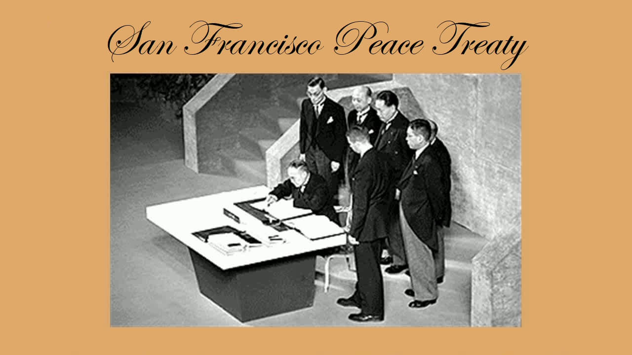

##### Quasi-trusteeships in US History

Under the US Constitution, the existence of the territorial category of "quasi-trusteeship" was recognized by the Supreme Court as early as 1901.

Up to the present day, we can find three major examples in US history.

###### US Overseas "Quasi-trusteeships"

Cuba 1899 to 1902

Ryukyus 1952 to 1972

Taiwan 1952 to present

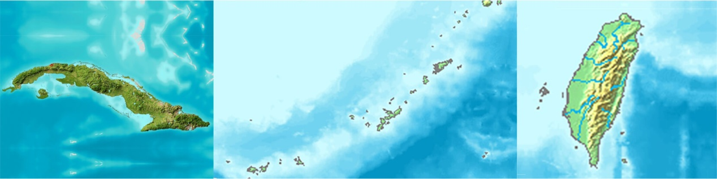

Further information on trusteeships and quasi-trusteeships is presented below.

Trusteeship Characteristics

A trusteeship is commonly defined as a territory whose administration has been entrusted to another country by the United Nations, under the authority of an individual trusteeship agreement.

From the US perspective, the US Constitution has a territorial clause (Art. 4, Sec. 3, Cl. 2) but no trusteeship clause.

Nevertheless, the US Supreme Court has recognized the existence of trusteeship type arrangements over certain territory which has come under US military jurisdiction.

**Overview of quasi-Trusteeships:** As analyzed in our series of three flowcharts, a US overseas "quasi-trusteeship" has the following characteristics under US law:

* The United States has provided significant economic and military support to the territory, and at the same time --
* The United States has undertaken broad military use and domination of the territory; moreover --
* This broad military use and domination has included the United States taking on the role of direct counterpart to any foreign countries which might contemplate an invasion. In addition --
* The post-war peace treaty has specified that the United States has final "disposition rights" over the territory, accordingly --
* The United States has dictated the terms of, and veto power over, any proposed future disposition of the territory.

Significantly, the above five characteristics are fully in line with international trusteeship practice and precedent.

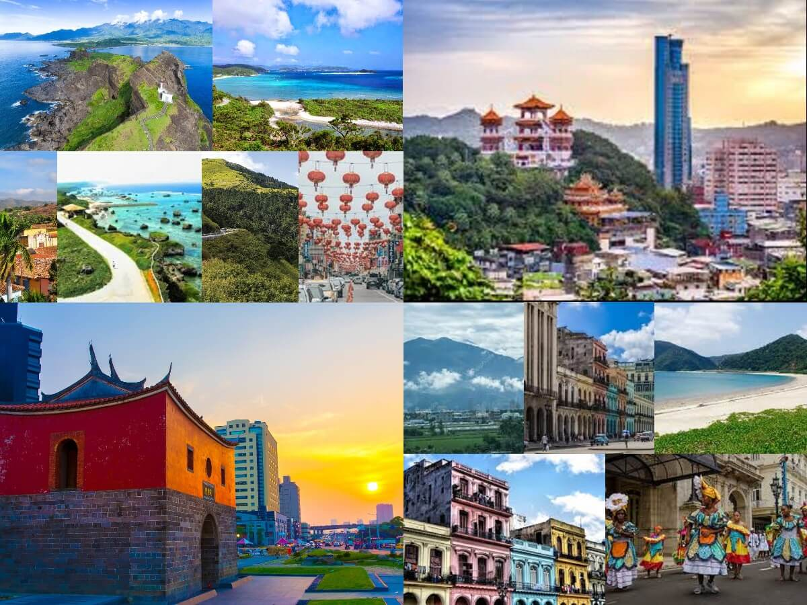

Further comparisons between re outlined below.

Further comparisons between Cuba, the Ryukyus, and Taiwan are outlined below.

Fundamental Attributes of US Overseas quasi-Trusteeships

Cuba, the Ryukyus, and Taiwan all have the following fundamental attributes:

* The territory was conquered/liberated by US military forces in a formally declared war.
* According to the customs and usages war, the United States serves as the "legal occupier" or so-called "principal occupying power."
* The territory was ceded by its original "mother country" in the post-war peace treaty, but no "receiving country" was specified.
* The jurisdiction of the US military authorities over the territory was specified in the post-war peace treaty.
* The administration of each territory has had many notable "trusteeship characteristics," even though no individual trusteeship agreement was ever formally concluded.

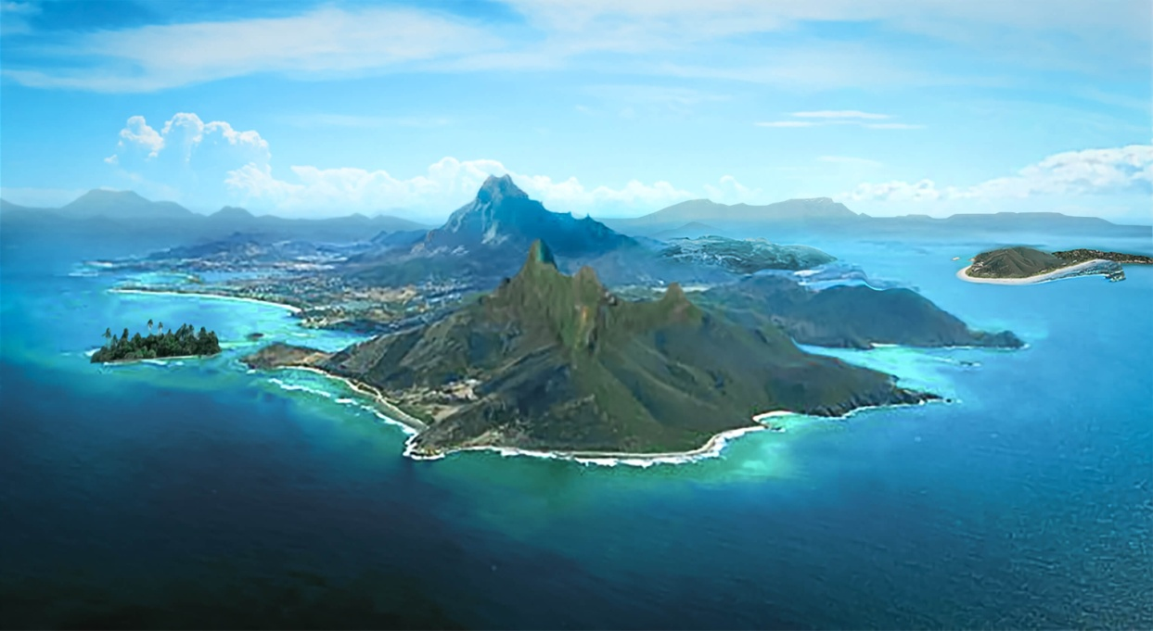

The US Supreme Court has held that "international law is part of our law." The findings regarding US

The US Supreme Court has held that "international law is part of our law." The findings regarding US overseas "quasi-trusteeships" presented on this website are based on US constitutional principles and legal criteria, while at the same time giving full respect to international law.

Importantly, these are the standards which US officials must apply when dealing with the Taiwan question.

As a paramount concern, US officials should revamp their Taiwan policy to faithfully implement the contents of the 1952 Senate-ratified San Francisco Peace Treaty. To date, the contents of this treaty appear to have been completely ignored.

|  |
| --- |
| Return to Flowcharts  https://www.twdefense.info/trust3/three.html |

Taiwan Autonomy Foundation

Los Angeles, California USA

<https://www.twdefense.info/trust3/quasi-ttrust.html>

This data is provided under the Creative Commons Attribution-ShareAlike License

CC BY SA